Audit Event

Contents

Overview of Audit 2
Creating Audit event using ORM stack 2

Pre-requisites:
- Audit event
- Topic – Created through ORM stack using Terraform.

Overview of Audit
Describes the Oracle Cloud Infrastructure Audit service, which automatically records calls to all supported Oracle Cloud Infrastructure public application programming interface (API) endpoints as log events.
Currently, all services support logging by Audit. Object Storage service supports logging for bucket-related events, but not for object-related events. Log events recorded by the Audit service include API calls made by the Oracle Cloud Infrastructure Console, Command Line Interface (CLI), Software Development Kits (SDK), your own custom clients, or other Oracle Cloud Infrastructure services.

Viewing Audit Log Events
Describes how to view Audit log events.
Audit provides records of API operations performed against supported services as a list of log events. The service logs events at both the tenant and compartment level.
When viewing events logged by Audit, you might be interested in specific activities that happened in the tenancy or compartment and who was responsible for the activity. You will need to know the approximate time and date something happened and the compartment in which it happened to display a list of log events that includes the activity in question. List log events by specifying a time range on the 24-hour clock in Greenwich Mean Time (GMT), calculating the offset for your local time zone, as appropriate. New activity is appended to the existing list, usually within 15 minutes of the API call, though processing time can vary.

Required IAM Policy
To use Oracle Cloud Infrastructure, you must be granted security access in a policy by an administrator. This access is required whether you're using the Console or the REST API with an SDK, CLI, or another tool. If you get a message that you don’t have permission or are unauthorized, verify with your administrator what type of access you have and which compartment to work in.
For administrators: The following policy statement gives the specified group (Auditors) the ability to view all the Audit event logs in the tenancy:
Allow group Auditors to read audit-events in tenancy.
To give the group access to the Audit event logs in a specific compartment only (ProjectA), write a policy like the following:
Allow group Auditors to read audit-events in compartment ProjectA

Creating Audit Event using ORM stack
Step 1: Open the navigation menu and click Developer Services and click Stack.

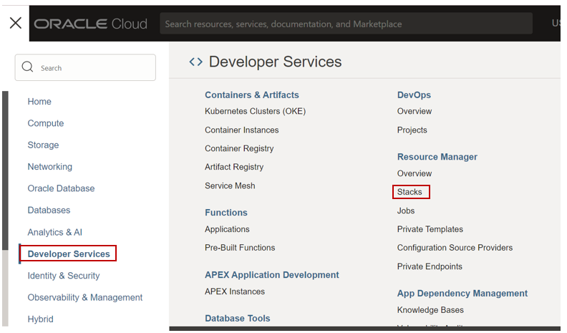

Step 2: Click on Stack and Click on create stack and upload the audit_event terraform folder.

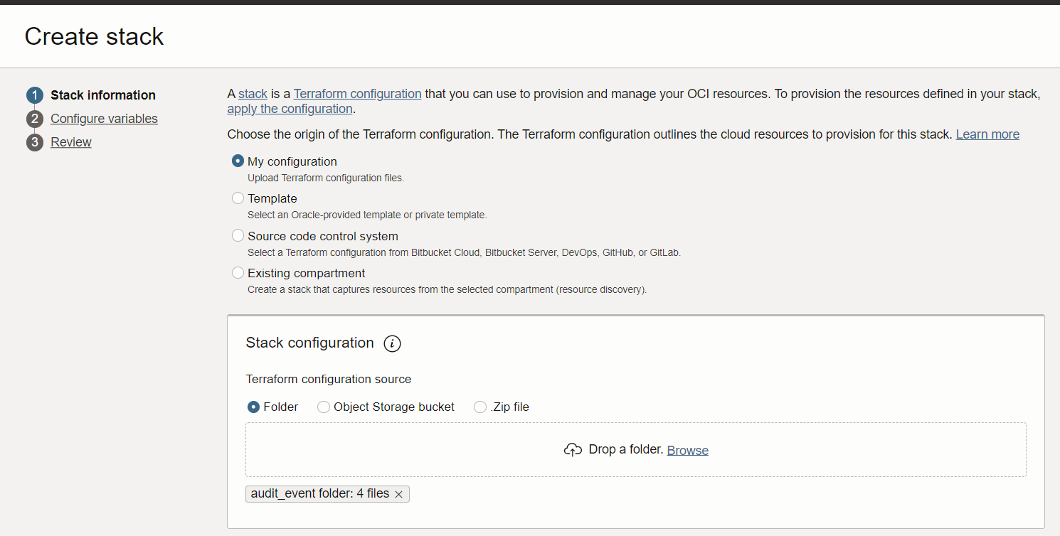

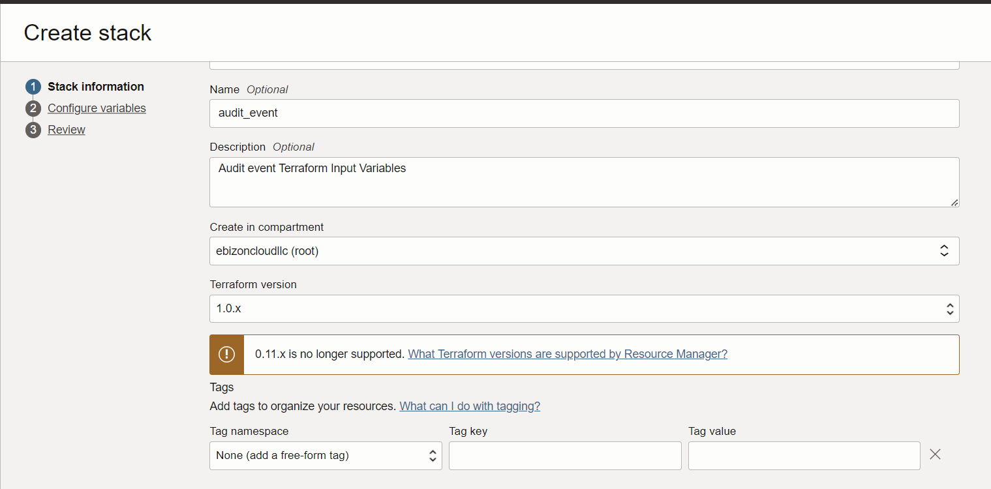
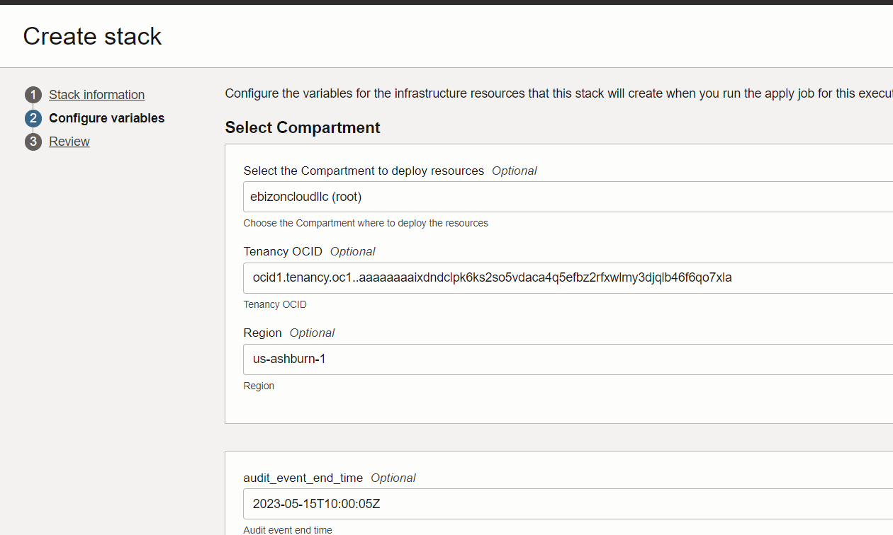

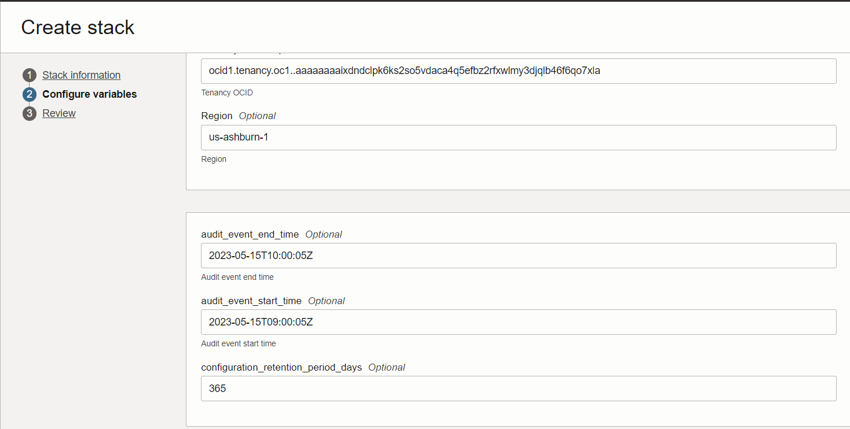

Step 3: Stack detail page click on Plan.
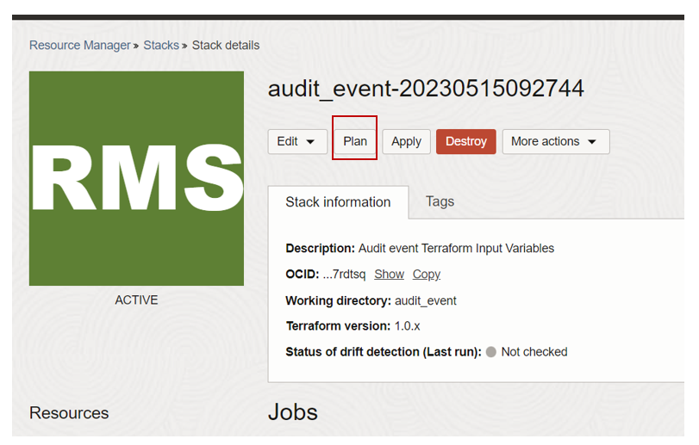Plan output
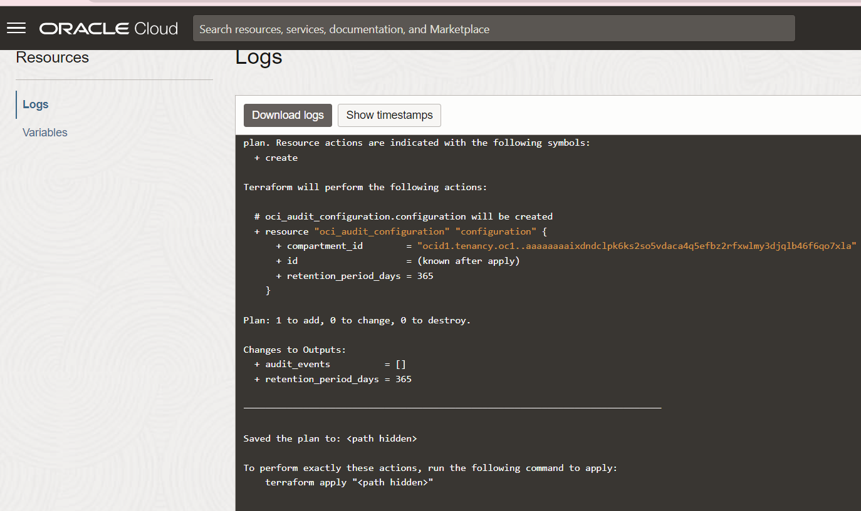

Step 4: Click on Apply
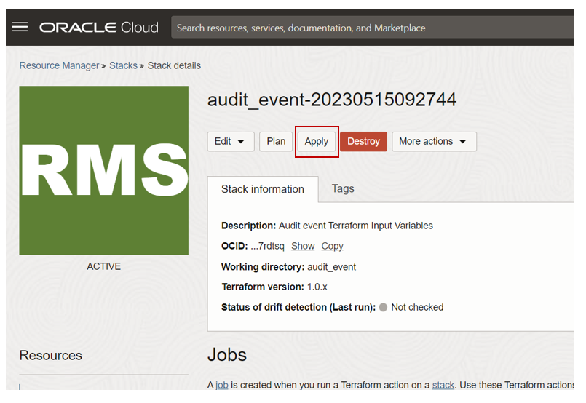
Apply output.
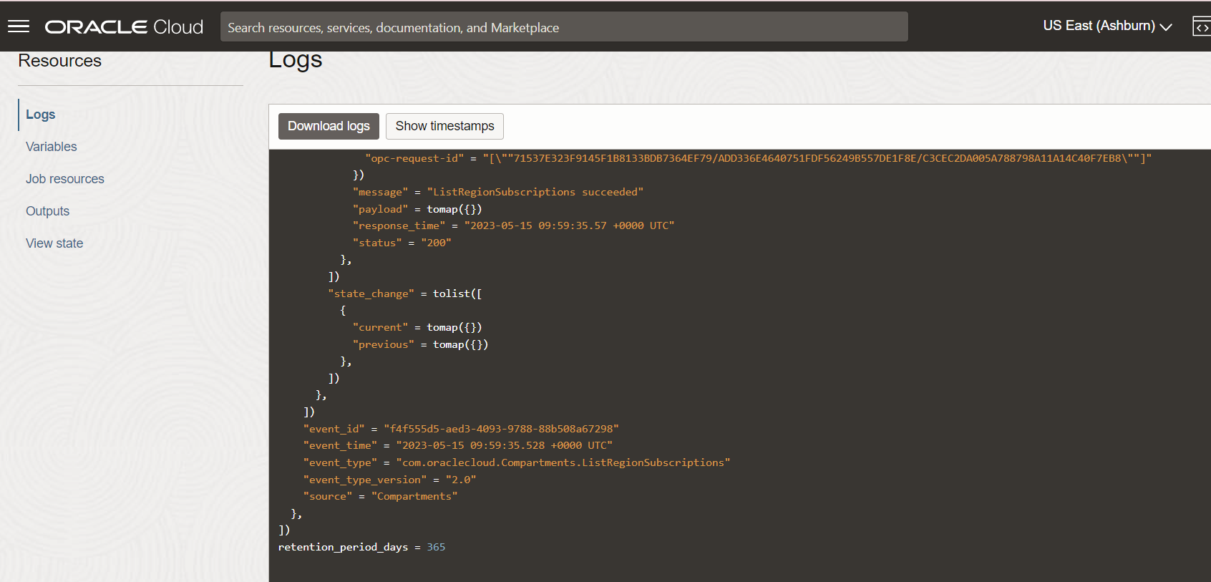

Step 5: Open the navigation menu and click Identity & Security. Under Identity, click Audit.

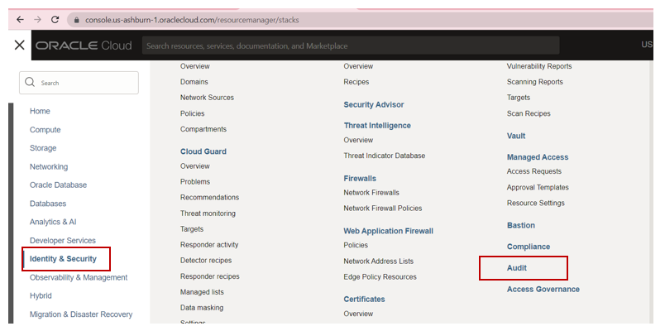
Output
